**GameAI Tank Price List**

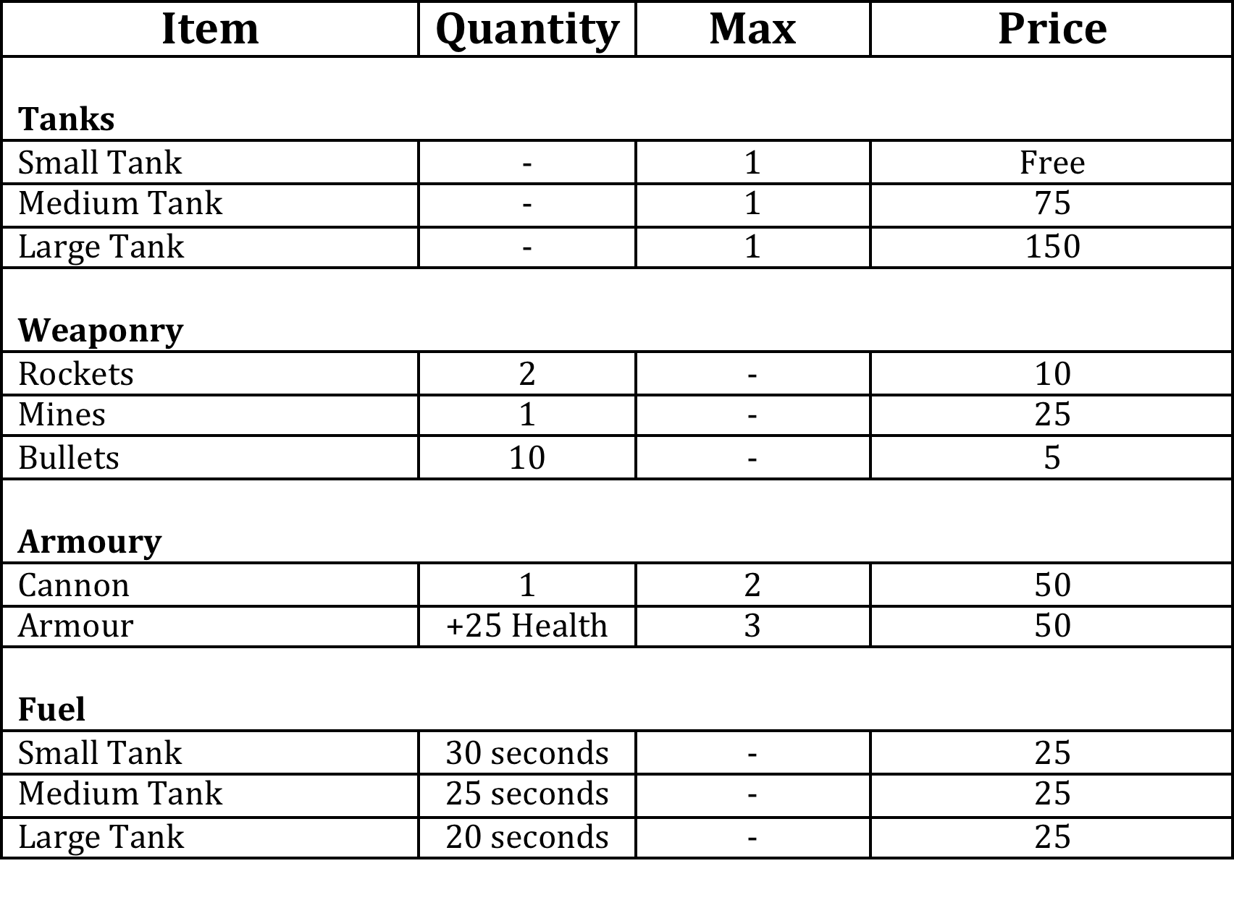

**Default Values for Tanks**

|  |  |
| --- | --- |
| **Small Tank** | **Starting QTY** |
| Rockets | 20 |
| Mines | 5 |
| Bullets | 50 |
| Health | 100 |
| Fuel [seconds] | 60 seconds |
| MaxSpeed | 90 |

|  |  |
| --- | --- |
| **Medium Tank** | **Starting QTY** |
| Rockets | 25 |
| Mines | 10 |
| Bullets | 100 |
| Health | 150 |
| Fuel [seconds] | 45 seconds |
| MaxSpeed | 75 |

|  |  |
| --- | --- |
| **Large Tank** | **Starting QTY** |
| Rockets | 30 |
| Mines | 15 |
| Bullets | 150 |
| Health | 200 |
| Fuel [seconds] | 30 seconds |
| MaxSpeed | 60 |

Note: Add your values onto these.